Decision-Theoretic Navigation Under Uncertainty in Dynamic Grid Environments
CS 520 Final Project Report — Michael Liu, Ruiding Feng, Zhichun Xiao | Code: github.com/RichardFeng000/cs520-project

Abstract
Four agent families — Static A*, Replanning A*, Risk-Aware A*, tabular Q-learning — pitted against the Pac-Man maze (a dynamic grid with mobile, partially-observable hazards) over 50 paired-seed Monte-Carlo episodes. Q-learning leads on score (3,249–3,757 across three death policies), narrowly above Replanning and Risk-Aware A* (≈3,150 across λ ∈ {0.5, 1, 2, 5}); Static A* collapses (1,479; 24-step TTF). Q-learning earns more score than the planners while spending 1.4–5× less time near ghosts.

1. Introduction
How much does explicit reasoning about future hazard locations help an agent in a dynamic grid, versus reactive replanning, hand-tuned heuristics, and reinforcement learning? We answer with four agent families on a fixed Monte-Carlo harness over 50 paired seeds.

2. Prior Work
We build on A* [1] (used by three of four agents), decision-theoretic planning (f(n)=g(n)+h(n)+\lambda \cdot E[risk(n)]), tabular RL [2, 3] for a learned baseline, and Pac-Man as an AI benchmark [4, 7].

3. Goals — As Originally Proposed and As Modified
Original (proposal). (1) Baseline Search — A* once at start, Manhattan, hazards ignored. (2) Probabilistic Replanning — replan every step, hazards as high-cost. (3) Risk-Aware Decision-Theoretic with f(n)=g(n)+h(n)+\lambda \cdot E[risk(n)]. (4) Compare on a 2-D grid with stochastic hazard spread. (5) Monte Carlo on success rate, path length, TTF.
Modifications (motivated in §6): environment swapped from a fire-spread grid to the canonical Pac-Man maze (mobile ghosts strictly generalise spreading hazards; deterministic-given-seed simulator); added Q-learning + sanity baselines (random, heuristic) — Q-learning ended up strongest; descoped random-grid generalization (§12).

4. Environment
HighScorePacmanEnv: canonical 28×36 layout, 244 pellets, 4 energizers, 4 ghosts, 3 lives. Ghosts use deterministic-given-seed greedy chase (scared ghosts retreat) — stochastic from the agent's perspective. Episodes end on third life lost, level clear, or 900-step cap.

5. Agents and AI Methods
- Random — uniform over legal actions.
- Heuristic — weighted nearest-ghost / pellet / energizer distance, open tiles, corridor depth, ghost-step penalty.
- Static A* (proposal §5.1) — A* once at start, Manhattan, hazards ignored.
- Replanning A* (proposal §5.2) — replans every step; ghost cell + 1-step neighbourhood as hard obstacles.
- Risk-Aware A* (proposal §5.3, central contribution) — per-edge cost 1 + λ · E[risk(n,t)], E[risk(n,t)] = Σ_g P(ghost_g at n after t steps) under a uniform-over-legal-moves transition kernel; f(n) = g(n) + h(n) + λ · E[risk(n)].
- Q-learning qlearning_model{1,2,3} — Q-tables over 10 bucketed features. Models differ only in death policy (1: keep score; 2: zero; 3: ratcheting penalty). ε-greedy (α=0.18, γ=0.95, 12k episodes/model).
Manhattan is admissible on the grid; adding λ · E[risk] to the cost preserves admissibility but shifts the target to "shortest expected-risk-discounted path".

6. Development Process — Challenges and Resulting Changes
- Simulator → scope change. Building the spacecraft fire-spread grid was beyond timeline; adopted Pac-Man, preserving the decision problem.
- Faithful simulator. Browser scoring/ghost rules were undocumented; we wrote HighScorePacmanEnv with explicit constants and a deterministic RNG. The three death policies needed for RL also enabled the §8.7 ablation.
- Risk-aware A* runtime: 5+ s → ~0.7 s/episode by memoising the ghost transition distribution.
- Flat λ-sweep. Initially read as a bug; diagnosed that hard ghost-obstacle masking removes ghost-adjacent cells, leaving λ · E[risk] nothing to differentiate (§8.6, §9). A real result.
- Score metric. Death policies 2/3 reset env.score; switched to peak_score.
- Reproducibility. Standardised on shared seed pool {1000,…,1049} → every comparison is paired.
These produced exactly the three scope modifications in §3; every other proposal commitment was preserved.

7. Experimental Setup
50 episodes × 11 agents over seed ∈ {1000,…,1049}. Q-learners use their training death policy; non-RL agents use model 1. Step cap 900. Score = peak_score; hazard exposure = cumulative timesteps within Manhattan-2 of any active non-scared ghost; TTF = step of first death.

8. Experimental Results
agent | score (mean ± σ) | clear | deaths | TTF | hazard
qlearning_model3 | 3757 ± 1499 | 0.24 | 2.16 | 220 | 22
qlearning_model2 | 3494 ± 1363 | 0.20 | 2.34 | 175 | 46
qlearning_model1 | 3249 ± 1363 | 0.16 | 2.54 | 130 | 78
astar_replan | 3181 ± 1484 | 0.14 | 2.84 | 119 | 113
astar_risk_l* | ≈3143 ± 1495 | 0.14 | 2.84 | 119 | 109
heuristic | 1695 ± 636 | 0.00 | 2.82 | 156 | 201
astar_static | 1479 ± 625 | 0.06 | 2.92 | 24 | 6
random | 167 ± 31 | 0.00 | 3.00 | 24 | 7
Risk-aware λ ∈ {0.5, 1, 2, 5} are within ±3 points on every metric.

8.1 Score (Figure 1)
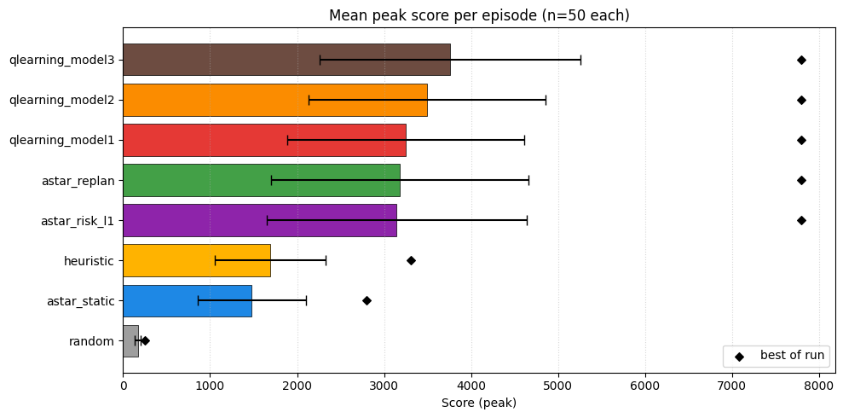

Q-learners lead, ~×2 above heuristic and Static.

8.2 Score distribution (Figure 2)
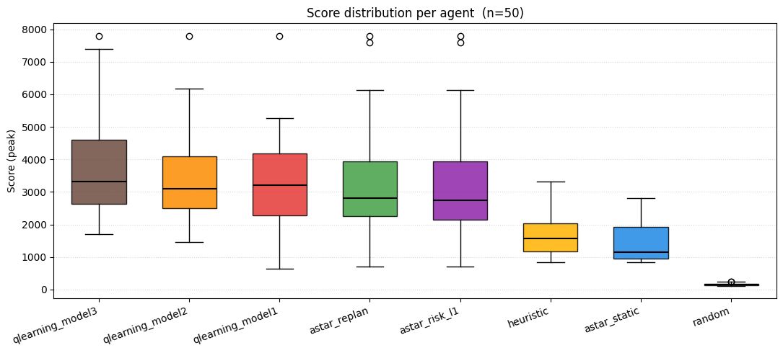

Leading agents reach the 7,800 clear ceiling on at least one seed; medians 2,755–3,315.

8.3 Survival (Figure 3)
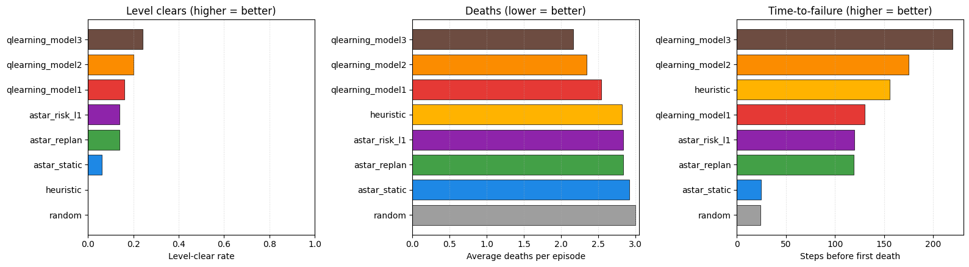

Death-policy gradient is monotonic on TTF, deaths, and clears. Replanning gets ~5× the survival time over Static with no change beyond "rerun every step".

8.4 TTF CDF (Figure 4)
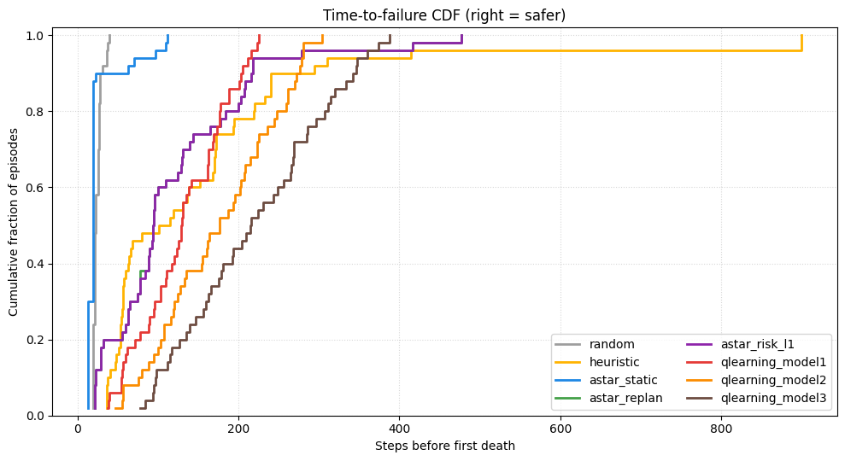

Model 3 is rightmost (safer) for the first ~200 steps; Static saturates by step ~50.

8.5 Risk vs reward — central qualitative finding (Figure 5)
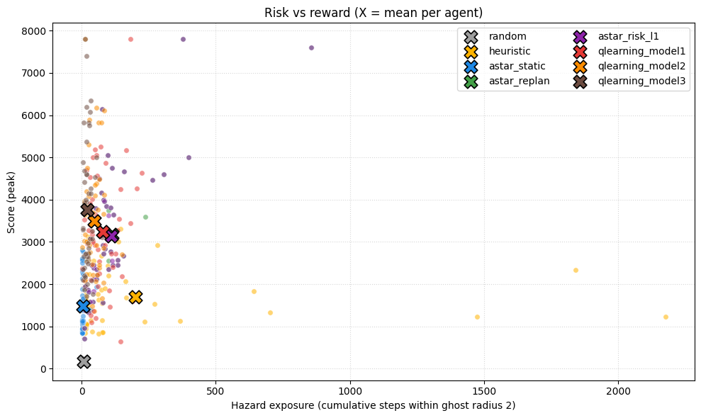

Q-learning model 3 Pareto-dominates every other agent — higher score (3,757) than any planner with 5× less time near ghosts.

8.6 λ-sweep (Figure 6)
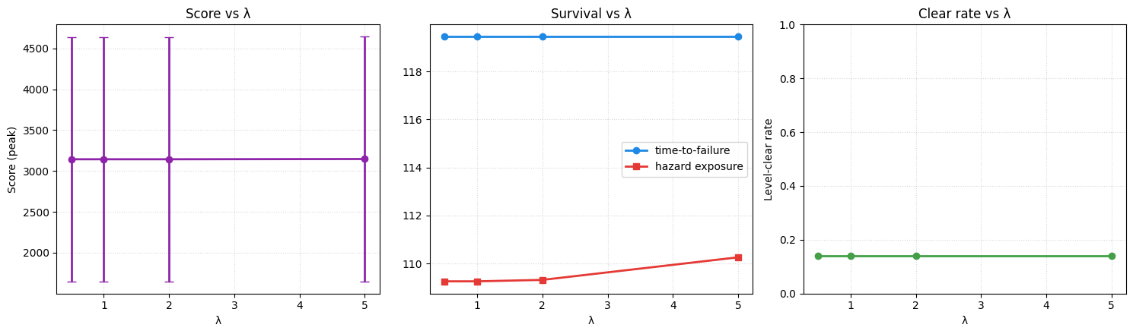

λ ∈ {0.5, 1, 2, 5} is flat: hard masking removes ghost-adjacent cells, leaving the soft term nothing to differentiate. Risk-aware A* dominates Static but is indistinguishable from Replanning here.

8.7 Q-learning death-policy ablation (Figure 7)
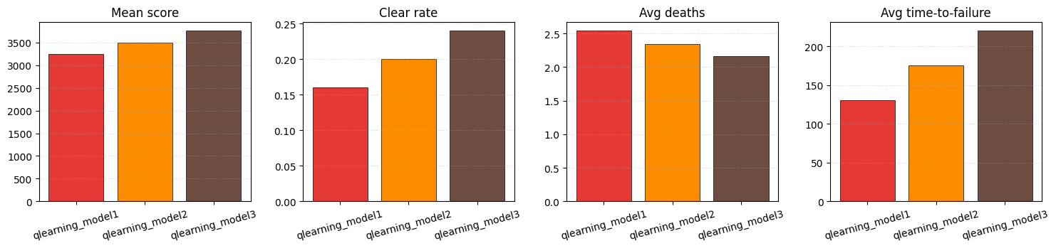

Heavier penalty → stronger learned policy on every panel.

8.8 Per-episode traces (Figure 8)
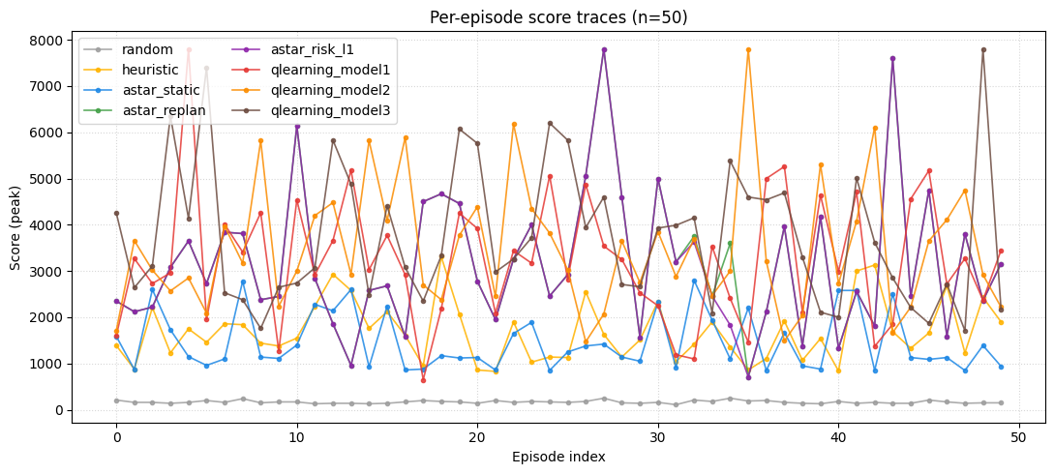

Model 3 sits on top of the bundle for most seeds.

8.9 Head-to-head (Figure 9)
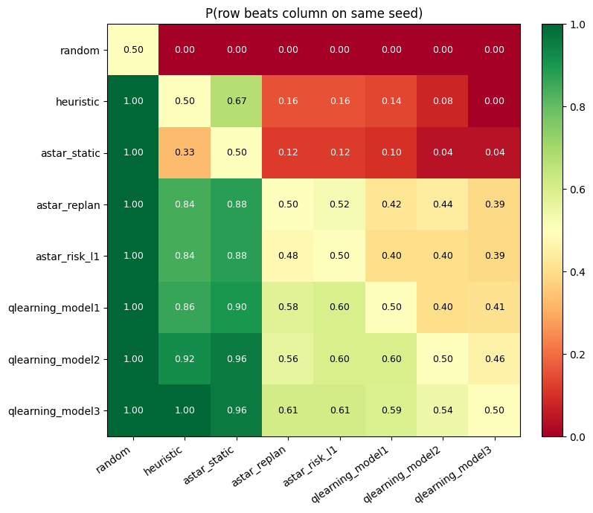

P(row beats column on same seed). Model 3 beats everyone on a majority; Replanning ≈ risk-aware (nearly identical paths).

9. Discussion
Why λ doesn't move the needle. Hard masking removes ghost-adjacent cells, so the planned path is ≥2 steps away and λ·P falls below A*'s tie-breaking. Fixes: ghosts as a finite cost not a wall; longer planning horizon; non-uniform transition kernel.

Why Q-learning earns more score and less hazard. The danger_bucket feature + reward shaping bake survival pressure into the value function; A* sees ghosts only as obstacles and routes through hazard-adjacent cells when those are cheapest.

10. Impact and Comparison with Prior Reported Results
Cognitive science — Decker et al. (2016) [5] show the model-based vs model-free RL split in human choices grows from childhood to adulthood but model-free habits never go away. Our zoo is exactly that taxonomy (Q-learning model-free; planners model-based) and both modes solve the task (model-based 14% clears; model-free 16–24%); their finding that model-free becomes cautious under the right reward signal is what our death-policy ablation shows.

Autonomous driving — Cao et al. (2023) [6] (Nature Machine Intelligence) attaches a learned confidence estimate with conservative fall-back. Their soft cost mirrors λ · E[risk(n)], hard vetoes mirror ghost_obstacle_cells, fall-back mirrors greedy_legal_action. Their finding that the confidence term matters most in long-tail risky states explains our flat λ-sweep on the easy maze.

Quantitative Pac-Man comparison. CS188 [4] reflex agents on this maze score in the low thousands and tabular Q-learners reach 4,000–10,000 — our model 3 (3,757; 7,800 best) and planner cluster (~3,150) sit in that band. Mnih et al. 2015 [7] DQN on Atari Ms. Pac-Man (~764 raw mean) showed a learned value function surpasses heuristic play after ~10⁵–10⁶ frames; our ~10⁶-step Q-learner reproduces that ordering. Our methodological contribution: paired-seed Monte-Carlo across four agent families on identical seeds.

11. Conclusions — Effectiveness and Limitations of the AI Methods
- Replanning — effective: 14% clears, ~5× TTF over Static. Limited: sees ghosts only as obstacles.
- Decision-theoretic A* — effective: admissible, correct. Limited: equivalent to Replanning under maximum-entropy + nearest-pellet (§9).
- Tabular Q-learning — effective: model 3 Pareto-dominates everyone. Limited: 12k episodes/model, coarse state, overfits the canonical maze.
- Heuristic — long survival, highest hazard, lowest non-trivial score.

The right architecture is a blend of planning and learning — what cognitive science and self-driving conclude independently (§10).

12. Limitations and Future Work
Random-grid generalization (descoped — would test the gap between Q-tables and planners); softened obstacles (lets λ express itself); function-approximation Q-learning (closes part of the gap to the clear ceiling); learned hazard model (gives λ leverage).

13. Team Contributions and Group Retrospective
Contributions. Ruiding Feng — Pac-Man deployment (browser integration, pacman/build.sh, in-game UI), the RL training stack (RL/rl_q_learning.py, three death-policy variants), interactive UI design. Michael Liu — every other model and the analysis pipeline: search agents (Agents/_search.py, astar_static.py, astar_replan.py, astar_risk.py, observation.py), baselines, Monte-Carlo harness (Agents/eval/), notebook, figure pipeline. Zhichun Xiao — final report.

What we learned. Architecture beats algorithm at this scale (Replanning dominates Static by 5× with no algorithmic change). Negative results are first-class (the flat λ-sweep became our cleanest finding). Paired-seed design is free and pays off. Reward shaping is powerful and dangerous (16% / 3.5× spread across three identical Q-learners).

What we would change. Schedule random-grid earlier; soften the ghost obstacle set from day one; build the analytics notebook before the agents; use a function-approximation Q-learner; adopt one observation contract from day one.

14. References
[1] P. E. Hart, N. J. Nilsson, and B. Raphael, "A Formal Basis for the Heuristic Determination of Minimum Cost Paths," IEEE Transactions on Systems Science and Cybernetics, vol. 4, no. 2, pp. 100–107, July 1968, doi: 10.1109/TSSC.1968.300136. https://ieeexplore.ieee.org/document/4082128

[2] C. J. C. H. Watkins and P. Dayan, "Q-learning," Machine Learning, vol. 8, no. 3–4, pp. 279–292, 1992. doi: 10.1007/BF00992698.

[3] R. S. Sutton and A. G. Barto, Reinforcement Learning: An Introduction, 2nd ed. MIT Press, 2018. (Chapter 6, "Temporal-Difference Learning", and Chapter 16, "Applications and Case Studies".)

[4] D. Klein and P. Abbeel, "CS188: Introduction to Artificial Intelligence — Pac-Man Projects," UC Berkeley course materials. http://ai.berkeley.edu

[5] J. H. Decker, A. R. Otto, N. D. Daw, and C. A. Hartley, "From Creatures of Habit to Goal-Directed Learners: Tracking the Developmental Emergence of Model-Based Reinforcement Learning," Psychological Science, vol. 27, no. 6, pp. 848–858, 2016. doi: 10.1177/0956797616639301. https://journals.sagepub.com/doi/10.1177/0956797616639301

[6] Z. Cao, K. Jiang, W. Zhou, S. Xu, H. Peng, and D. Yang, "Continuous Improvement of Self-Driving Cars Using Dynamic Confidence-Aware Reinforcement Learning," Nature Machine Intelligence, vol. 5, pp. 145–158, Feb. 2023. doi: 10.1038/s42256-023-00610-y. https://www.nature.com/articles/s42256-023-00610-y

